Installing Linux (Ubuntu Server / CentOS) on VirtualBox / VMware? Basic System Configuration (Hostname, Static IP, SSH Setup)? Managing Users & Groups

Tasks

1. Install Ubuntu Server (or CentOS) on VirtualBox or VMware, take a screenshot of your running login screen, and save it as install_success.png.

ANS:

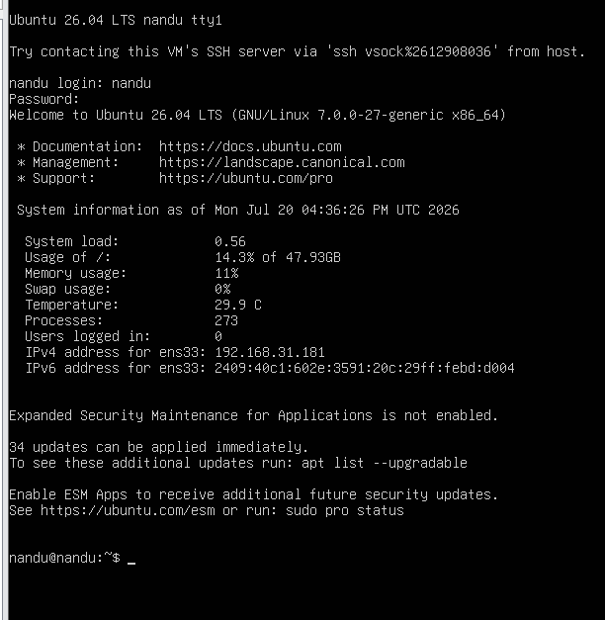

2. Change the hostname of your Linux VM to 'myfoodiebox' using the hostnamectl command, then verify the change by running the hostname command.

ANS:

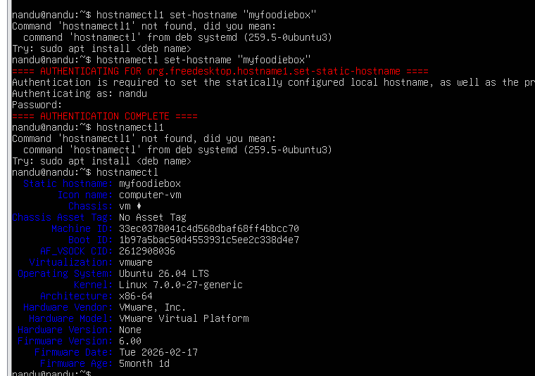

3. Configure a static IP address for your VM's network interface (e.g., enp0s3 or eth0) so that it always gets the same IP on reboot.<br><br><em><strong>Hint:</strong> Edit /etc/netplan/*.yaml (Ubuntu) or /etc/sysconfig/network-scripts/ifcfg-eth0 (CentOS), then restart networking.</em>

ANS:

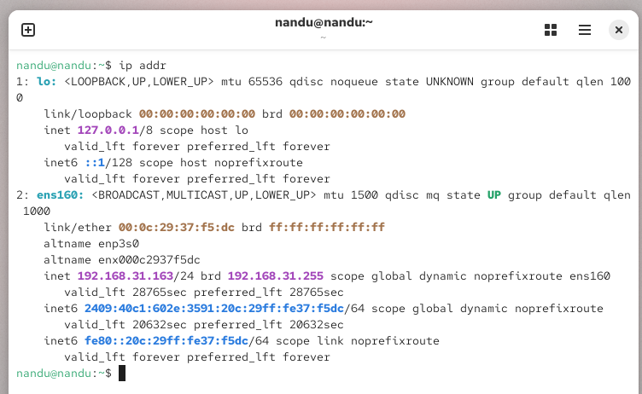

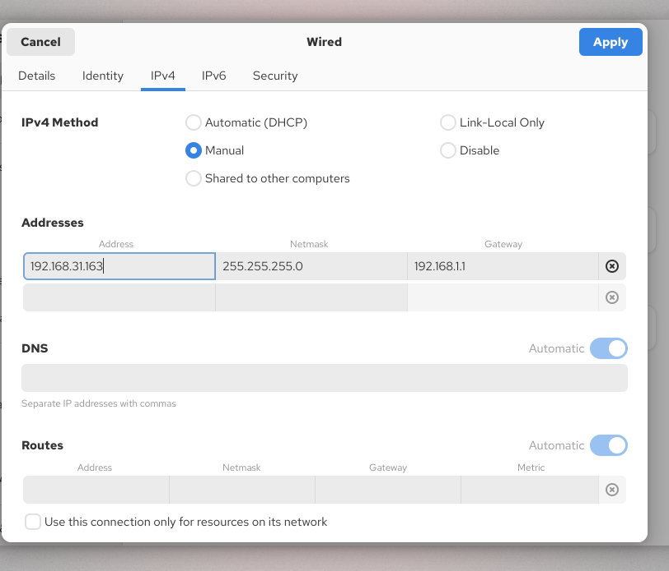

4. Enable SSH access on your Linux VM and connect to it from your host machine using an SSH client (like PuTTY or ssh command). Show the output of whoami after login.

ANS:

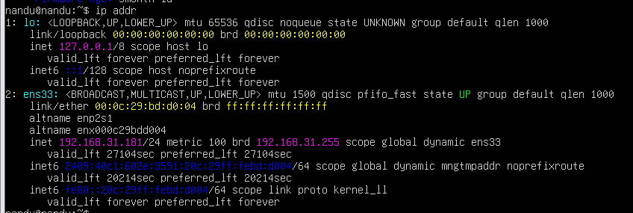

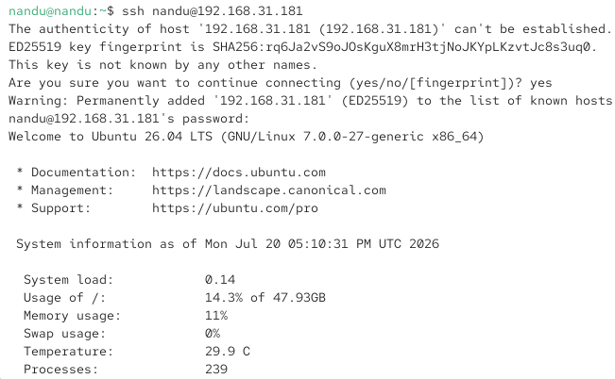

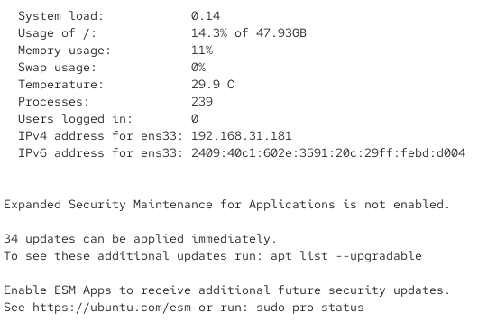

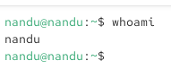

5. Create a new user named 'zomatouser' and add them to a new group called 'foodies'. Set their password and verify group membership using the groups command.

ANS:

